|  |  |  |  |  |
| --- | --- | --- | --- | --- |
| **National University of Computer and Emerging Sciences, Lahore Campus** | | | | |
| C:\Users\saif\AppData\Local\Microsoft\Windows\Temporary Internet Files\Content.Word\final design.jpg | **Course Name:** | **Database Systems** | **Course Code:** | **CS2005** |
| **Degree Program:** | **BS (CS, DS, SE)** | **Semester:** | **Spring 2023** |
| **Exam Duration:** | **3 Hours** | **Total Marks:** | **75** |
| **Paper Date:** | **Thu 25-May-2023** | **Weight** | **50%** |
| **Section:** | **ALL** | **Page(s):** | **12** |
| **Exam Type:** | **Final Exam** | **Total Questions:** | **9** |
| **Instruction/Notes:** | Scratch sheet can be used for rough work however, all the questions and steps are to be shown on question paper. ***No extra/rough sheets should be submitted with question paper***.  You will not get any credit if you do not show proper working, reasoning and steps as asked in question statements. | | | |

|  |  |  |  |  |  |  |  |  |  |  |
| --- | --- | --- | --- | --- | --- | --- | --- | --- | --- | --- |
| CLO No. | *3* | | *6* | | | | | | | Total |
| Q. No. | 1 | 2 | 3 | 4 | 5 | 6 | 7 | 8 | 9 |
| Marks |  |  |  |  |  |  |  |  |  |  |

|  |
| --- |
| **Roll No:** ____________________ **Section:** __________ **Name:** ______________________________ |

**Q1.** *(5 points)* Consider the following schedule of four transactions T1, T2, T3, and T4.

**S:**  r1(X), r2(X), r3(X), w4(Y), w2(X), r3(Y), w2(Y).

Draw the serializability (precedence) graph for this schedule. State whether this schedule is (conflict) serializable or not. If the schedule is serializable, write down the equivalent serial schedule(s) otherwise explain why it is not.

**Ans:**

**S: r1(X), r2(X), r3(X), w4(Y), w2(X), r3(Y), w2(Y).**

**It is conflict-serializable and equivalent serial schedules are 1) T1🡪T4🡪T3🡪T2; 2) T4🡪T1🡪T3🡪T2; 3) T4🡪T3🡪T1🡪T2.**

X

Y

X,Y

Y

**Q2.** *(10 points)* Map the following ER/EER Diagram into a relational model and specify all the constraints including primary key, foreign key, not null, and unique.

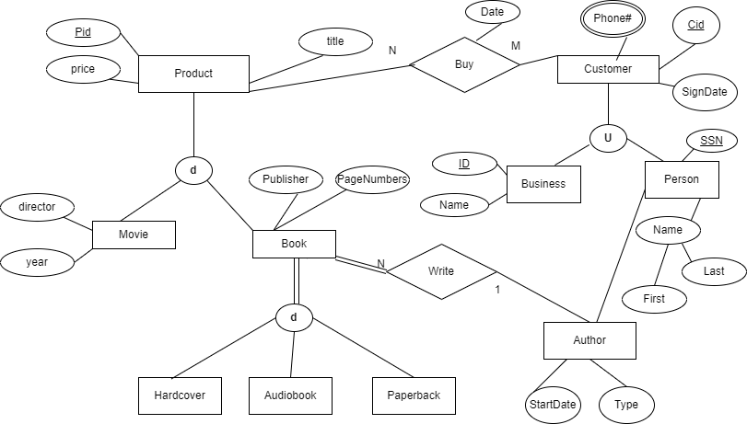

**Consider the following SOFTEC database for the next two questions:**

*SOFTEC* holds Software Competitions each year where Teams of students from various universities participate and present their projects. Some expert University Professors from around Pakistan are invited as judges. Judges evaluate **at max** five projects and give points to each Project on a scale of 1-10. Each Project is evaluated by exactly three judges, and the Project with the maximum points wins the competition. SOFTEC also gives cash prizes to the runner-up and third team.

|  |  |  |  |  |  |  |  |  |  |  |  |  |  |  |  |  |  |  |  |  |  |  |  |  |  |  |  |  |  |  |  |  |  |  |  |  |  |  |  |  |  |  |  |  |  |  |  |
| --- | --- | --- | --- | --- | --- | --- | --- | --- | --- | --- | --- | --- | --- | --- | --- | --- | --- | --- | --- | --- | --- | --- | --- | --- | --- | --- | --- | --- | --- | --- | --- | --- | --- | --- | --- | --- | --- | --- | --- | --- | --- | --- | --- | --- | --- | --- | --- |
| **JUDGE**   |  |  |  | | --- | --- | --- | | judgeID | name | university | | 1 | Tahreem | FAST | | 2 | Izaan | NUST | | 3 | Isbah | LUMS | | 4 | Ismail | LUMS | | 5 | Alia | NUST | | |  |  |  |  | | --- | --- | --- | --- | | **TEAM** |  |  |  | | *teamID* | *name* | university | city | | 1 | Hero | FAST | Lhr | | 2 | Xero | LUMS | Lhr | | 3 | Evilx | FAST | Isl | | 4 | Fame | NUST | Isl | | 5 | Daark | UMT | lhr | |
| |  |  |  | | --- | --- | --- | | **PROJECT** |  |  | | projectID | Title | teamID | | 1 | StarMiner | 1 | | 2 | Chatgpt++ | 4 | | 3 | NextLevel | 1 | | 4 | IOTmaster | 2 | | 5 | RoboX | 3 | | 6 | Webzz | 5 | | |  |  |  | | --- | --- | --- | | **ASSIGNED** |  |  | | judgeID | *projectID* | point | | 1 | 2 | 5 | | 1 | 3 | 6 | | 2 | 4 | 5 | | 3 | 4 | 7 | | 3 | 5 | 4 | | 4 | 2 | 3 | |

**Q3.** *(10 points)* Consider the database state given above and for each of the following queries, **(i)** Give the output for the database state given above and **(ii)** Explain in one simple English sentence what these queries are trying to do (achieve).

1. R(PID, JID) ←  projectID, judgeID Assigned

S(PID) ←  projectID ( city =‘Isl’ (Project * Team) )

Temp←  JID( S x ( JID(R) ) – R)

Result ←  JID(R) - Temp

1. SELECT J.judgeID, J.name  
   FROM Judge J  
   WHERE EXISTS (SELECT * FROM Assigned A

WHERE A.judgeID = J.judgeID AND

J.university IN (SELECT university from Project P join Team T

on P. teamID = T. teamID and T.university = J.university)

);

**Ans:**

1. **Find the judges who have evaluated all the project from universities in Islamabad**

|  |  |
| --- | --- |
| Result   |  | | --- | | JID |   Null |

**b) Find the judges who are assigned projects from the university they are associated with.**

**judgeID name**

|  |  |
| --- | --- |
| 1 | Tahreem |
| 2 | Izaan |
| 3 | Isbah |
| 4 | Ismail |

**Q4.** *(15 points)* Consider the above SOFTEC database for the following problems.

1. Write SQL and RA statement to list the name and ID of the Judges who have evaluated more than three projects and have given each project less than 5 points.
2. Write SQL and RA statement to list the name of the Judges who are from the same university as “Dr. Ali Pasha” and are assigned all the projects that are assigned to “Dr. Ali Pasha”.
3. Create a View that lists the Project ID, Title, TeamID and the number of Judges currently assigned to that project.

**Q5.** *(5 points)* Consider two sets of FDs, F and G, *F = {A → B, C → D, AB → C, AB → D, E → F}* and *G = {A → BC, C → D, E → F, ABC → D}*. Are F and G equivalent? Prove it.

**Ans: Both sets are equivalent.**

**Q6.** *(5 points)* Find a minimal cover of *F = {A → B, C → D, E → F, AB → D, AB → C}*. Show all steps.

**Ans: *Fc = {A → B, C → D, E → F, ~~AB → D~~ , A~~B~~ → C}*** *or* ***Fc = {A → BC, C → D, E → F}.***

**Q7.** *(4 points)* Consider the relation R (A, B, C, D, E), with FDs *F= {A → CD, B → CE, E → B}*. State which of the following decompositions of R relation are lossless decomposition. Prove it.

1. *R1(A, E), R2(B, E), R3(A, C, D)*
2. *R1(A, B), R2(B, C, E), R3(A, C, D)*

**Ans: Keys of R are AB & AE.**

**a) Lossless decomposition. *R1(A, E), R2(B, E), R3(A, C, D)* (R1∩R2)→R2 & (R1∩R3)→R3**

**b) Lossless decomposition. *R1(A, B), R2(B, C, E), R3(A, C, D)* (R1∩R2)→R2 & (R1∩R3)→R3**

**Q8.** *(6 points)* Consider the relation schema R (A, B, C, D, E, F), with FDs *F= {A → BC, B → D, CF → E, E → F}*. Suppose *{AE}* and *{AF}* are the two possible keys of this relation. Show all steps, working, and reasoning to answer the following questions.

1. Identify the best normal form that R satisfies (1NF, 2NF, 3NF, or BCNF). Justify your answer.

Clearly show the complete set of schema relations for each of the following parts with all keys and FDs and also indicate which dependencies if any are lost.

1. Decompose the relation R into a 2NF schema if it is not in 2NF. *(Remove 2NF violations only, in this part)*
2. Check whether your answer to part **(b)** is in 3NF. If not, decompose it into a 3NF schema. *(Remove 3NF violations only)*
3. Check whether your answer to part **(c)** is in BCNF. If not, decompose it into a BCNF schema.

**Ans:**

**a) HNF=1NF as FD1: A → BC violate 2NF;**

**b) 2NF Schema is R1(A E F) with FD4: E→F and keys are AE & AF**

**R2(A B C D) with FD1: A→BC & FD2: B→D**

**FD3: CF→E is lost**

**c) 3NF Schema is R1(A E F) with FD4: E→F and keys are AE & AF**

**R21(A B C)**

**R22(B D)**

**d) BCNF Schema is R11(A E)**

**R12(E F)**

**R21(A B C)**

**R22(B D)**

**Q9.** *(15 points)* Draw an ER/EER diagram (using notation discussed in lectures) for the above scenario. Specify all constraints that should hold on to the database and state any assumptions you make.

In the Medical System, **patients** receive medical care from doctors in a healthcare facility. Each patient is assigned a unique ID and has attributes such as name, address, and phone number. **Doctors** providing medical care also have unique IDs and possess attributes, including their name, specialization, address, and phone number. Patients can schedule appointments to see doctors for medical consultations. Each **appointment** has a unique ID, date, time, and reason for the visit. A patient can have multiple appointments scheduled with the same doctor on different dates. During the medical consultation, doctors may prescribe medications to patients. A **prescription** is identified by a unique ID and contains information such as the date and dosage instructions. A doctor can issue multiple prescriptions for different patients. Medical records are maintained for patients, capturing their medical history and treatments received. A medical record is represented by a unique ID and includes the patient ID, doctor ID, date of the record, diagnosis, and treatment details. Each patient can have multiple medical records associated with different doctors. Patients can undergo various tests to aid in diagnosis. The medical tests are recommended by doctors and have a unique ID, date, and results. In certain cases, doctors may refer patients to other specialized doctors for further evaluation or treatment. We keep track of the date of referral and the reason for the referral. A doctor can make multiple referrals for different patients.